Joe Ponsetto
Inversion of S-parameters
Key Parts:
1. Physical concepts of S11, S21, mu, epsilon, index and impedance; both real and imaginary parts.
2. S11, S21 ➔ mu, epsilon
➔ index, impedance
3. Implementation of Nathan Landy’s code
4. [e^+/-i(theta)] ; [phase-within-material issues] ; [branch and root errors]
5. cite sources: CST files, papers, books, code

1. Definitions of S11, S21, mu, epsilon, index and impedance:

Scattering and transmission coefficients:
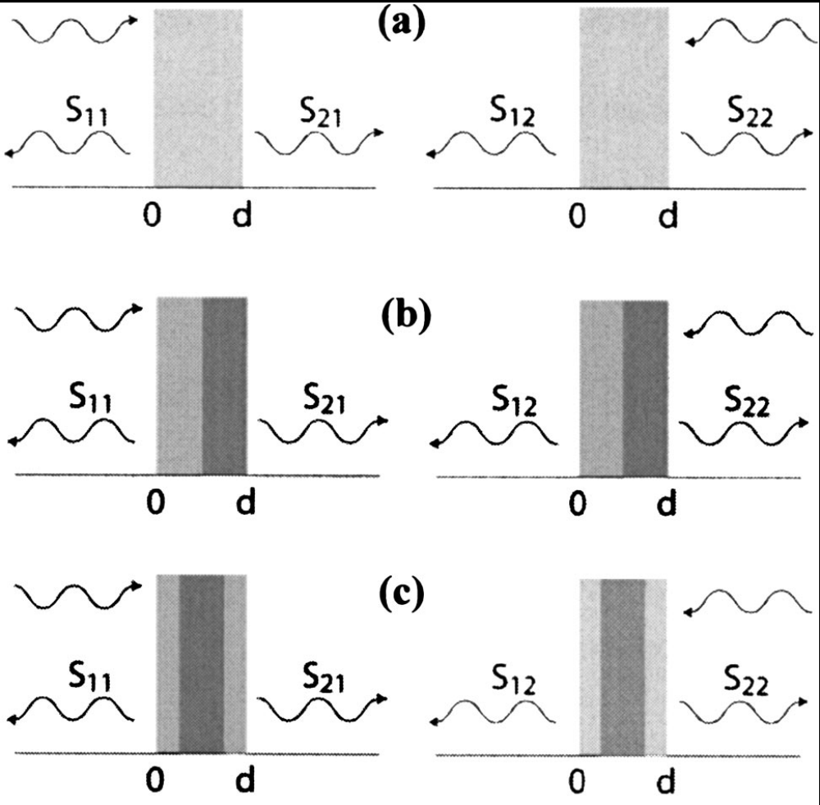
S11: S11 is a parameter which represents the intensity of the reflected wave relative to the intensity of the incident wave in a ratio, S11=b1/a1, where a1 and b1 are normalized intensities of the incident and reflected waves, respectively, on the foremost (according to the incident propagation direction) surface of the medium in question. When b1 is zero, then there is no reflected wave, so S11 is also equal to zero. When b1 equals a1, then there is 100% reflection, so S11 is equal to 1.
S21: S21 is a parameter which represents the intensity of the transmitted wave relative to the intensity of the incident wave in a ratio, S21=b2/a1, where a1 and b2 are normalized intensities of the incident and transmitted waves, respectively. The a1 being used here is the same as that used above in defining S11. The transmitted wave is the wave which is neither reflected nor absorbed, but passes through the entirety of the medium and continues along its path. When b2 is zero, then there is no transmitted wave, so S21 is also zero. When b2 equals a1, then there is 100% transmission, such that nothing is being either reflected or absorbed, so S21 is equal to 1.

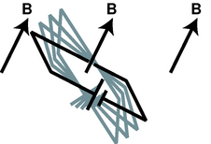
Permeability (μ): This optical constant is defined by B= μH. B is the magnetic field, and H is the auxiliary magnetic field. Physically, μ represents the degree to which surface current and magnetic dipoles within a given material will migrate or align with the H-field and add to (or subtract from!) the B-field. This relationship can exhibit hysteresis, since once the dipoles are already aligned the situation will be different. The quantity μ is not necessarily single valued or linear, and due to dispersion it is a function of frequency. It is generally represented by a complex number.
Permittivity (ε): This optical constant is defined by D= εE, at least in isotropic mediums. Analogous to permeability, ε shows how electric dipoles align themselves with an electric field E to create and electric displacement field D. Since the mediums through which EMR travels are dispersive, permittivity varies with frequency. Permittivity is a complex quantity, who’s real and imaginary parts are related through the Kramers-Kronig relation.
Index of refraction (n): In optics, this constant is defined by n=c/vp. The speed of light in a vacuum is c, and vp is the phase velocity of the “light” (more generally, EMR) in the given medium of index n. So physically, we can see that an index of 1 means that EMR passes through as if the medium were a vacuum, while a high index would slow light down considerably. Index is also used in Snell’s law. Index can be described by
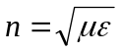. Due to this relationship, interesting properties may be observed by creating materials in which μ and ε have values such that n is negative.
Impedance (z): This constant is defined as the ratio of the electric and magnetic fields perpendicular to the propagation direction; 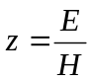. Impedance can also be described by 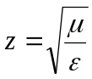. When permeability and permittivity are equal, then z=1 and it is said to be impedance-matched. This means that there will be zero reflection. Generally, when z deviates from unity, reflection increases.

2. Getting optical constants from scattering and transmission coefficients

Equations:

First, we can define 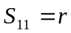, and 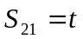, where 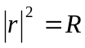 and 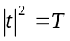
Below, we define t and r in terms of impedance and index of refraction, where 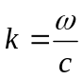 and d is the thickness of the medium.

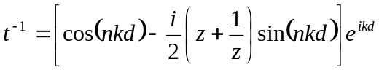
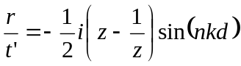

t' is defined as 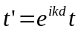
By inverting these equations, we can get n and z in terms of the scattering parameters:
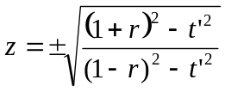

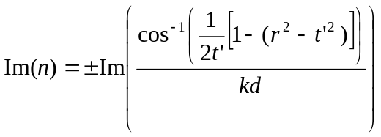

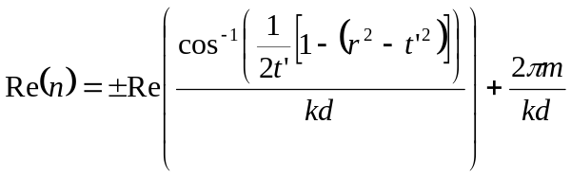

(where m is an integer)

The ambiguities in these equations can often be resolved by other known properties of the material in question.

3. Implementation of Nathan’s Code

In this section, an in depth explanation of Nathan Landy’s EM extraction code (which is appended to this document) is given. There are both VBA and MATLAB components to the extraction, and this explanation follows the code as it is executed.

First, commands are made such that MATLAB will be open and running for use in computations later in the code. For this reason, the first time you run the extraction you can expect a slight delay as MATLAB initiates (unless it is already open). Then, a path for the to-be-calculated data is made.
Next, there are many variables to define. In general, scalar values are dimensioned as double-precision scalars. The data that will be imported from CST is more complicated, and thus requires being dimensioned as a more abstract “object.” The variable nf is dimensioned as “long” because it is at least potentially a very long integer. In order to create arrays of the appropriate size, all the “double” variables are re-dimensioned as having the same size as the number of frequency steps from CST.
Next, the frequency-dependent scattering parameters obtained through CST’s transient solver are imported as objects. In a quick for loop, these objects are turned into x-y frequency dependent graphs.
Now MATLAB/ActiveX interaction is required. ActiveX is a windows component that facilitates interaction between two software programs, in this case CST and MATLAB. The code used in CST macros is Visual Basic for Applications (VBA), which cannot compute imaginary numbers. Breaking numbers into real and imaginary components also presents computational difficulties because it requires hyperbolic trigonometry and very large numbers, among other things. So to do the computations shown in part (2) of this document, it is necessary to use MATLAB. So the matrices created from the CST results are loaded into MATLAB, and then MATLAB is told to execute an M-file. This M-file performs the necessary complex computations, and is a part of the extraction code.
The M-file is a separate document which must be saved in the path defined as “user_path” earlier in the VBA code. First, ε0 and μ0 are defined. Data is then called from VBA. The phase and magnitude of the scattering parameters are combined to create the complex values. Then the code solves for the complex permeability and permittivity using Smith’s equations. In passive materials, EMR cannot gain energy, it can only lose it, therefore the imaginary component of the index and impedance must always be positive, so the appropriate corrections are made. The values of ε and μ can then be described in terms of n and z. From there, MATLAB is instructed to split all four of these values into real and imaginary components, leaving us with eight frequency-dependent plots.
However, none of the above calculations take into account spatial dispersion. Using a paper by Ruopeng Liu, Nathan defines the phase advance of light as it passes through a given medium with thickness d, and a certain μ0 and ε0. Also using Liu’s paper, he defines a second parameter in terms of theta which when multiplied by effective epsilon and effective mu generates epsilon average and mu average, respectively. Lastly, these new values are also split into real and imaginary components before they are ready to be transferred back to the CST macro.
Back in the VBA script, the computed data is called back from MATLAB to CST. The final task of this extraction is to create graphs to display in CST’s results section. Any data to be displayed is first saved as a file. It is then opened by CST and the data is printed as an x-y graph with the appropriate color, labels, and units. This is done for the real and imaginary components of epsilon effective, mu effective, effective index and effective impedance.

4. Miscellaneous issues of interest

A.) 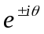:
Near the beginning of the MATLAB code, the complex S11 and S21 are created using the magnitude and phase from CST. This combination has the form Aexp([+/-]iθ), where A is the magnitude and θ is the phase. The plus or minus sign is really an arbitrary choice convention; this extraction follows Smith’s lead and uses the negative sign.

B.) Phase reference point:

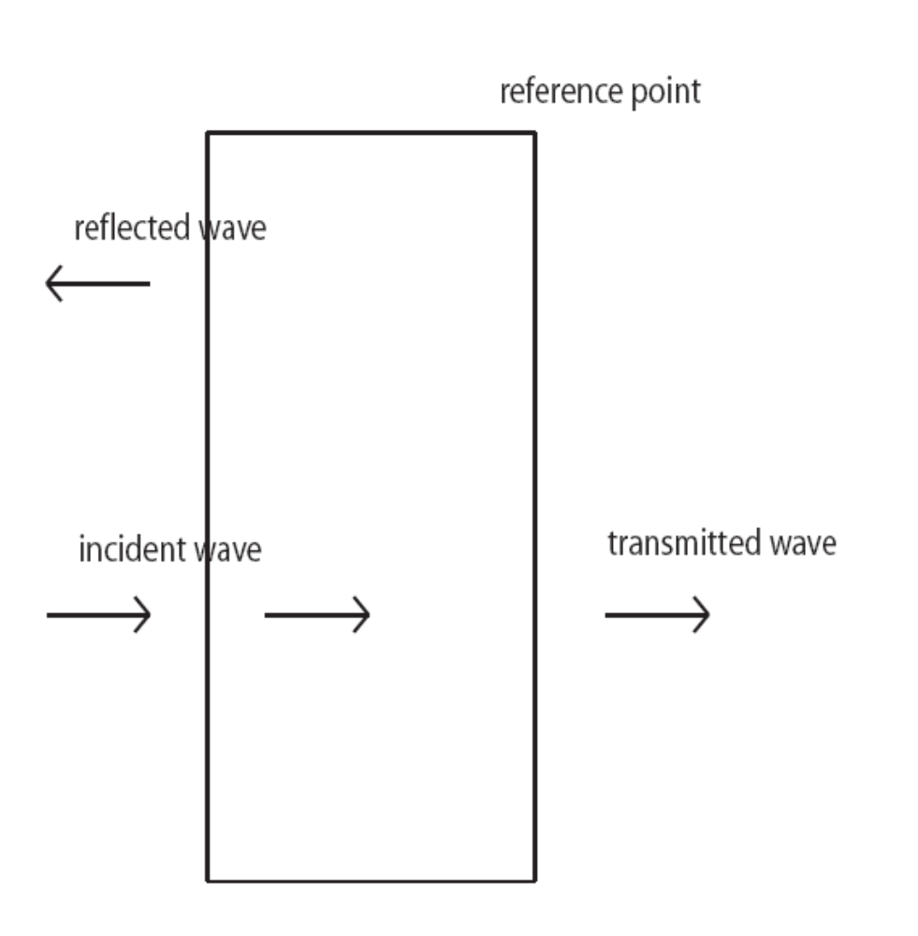

Another convention Smith chooses to use and we will follow in using his equations is the placement of his reference point for zero phase. Many physicists use the initial surface (first along the propagation direction) as the reference point, but Smith uses the “back” surface, farthest along the path of propagation. This is shown in his definition of t’ (also shown in part [2] of this document) where t’ differs from t by a facto of exp(ikd), which accounts for the phase advance through the material which is normally after the reference point rather than before it.

C.) Branch and Root errors:

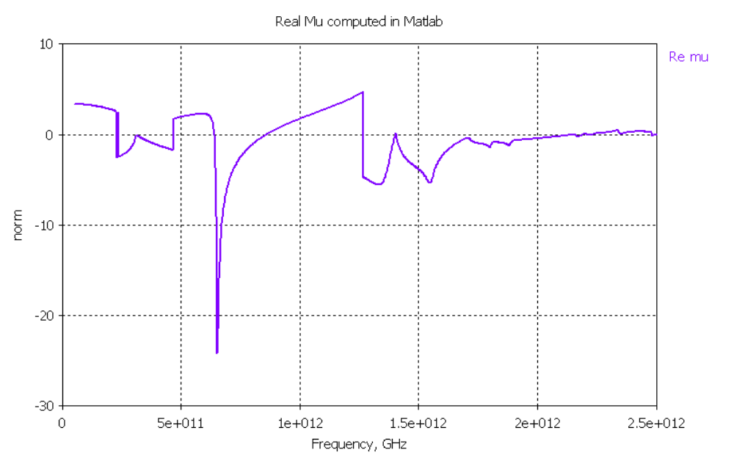

When a computer makes computations, any opportunities for ambiguity are a cause for concern. Two results of ambiguities that can potentially occur are root errors and branch errors. Root errors come from the square root of a number being computed incorrectly as either positive or negative. However, in this extraction, root errors have been fixed by assuming materials are passive, and therefore the imaginary components of n and z must always be positive (See section [3] of this document, and Nathan’s code [attached]).Branch errors do occur in the graphs of this extraction. They are caused when MATLAB computes an arccosine. No matter how big the argument is, MATLAB will always keep the first branch, which may not always be the correct branch. This can be fixed by the human eye by adding multiples of 2π/kd to the region in error until the graph becomes continuous.

5. Appendices:

Attached are the following: (***NOT YET!)

1. Description and explanation of electromagnetic behaviors in artificial metamaterials based on effective medium theory
Ruopeng Liu, Tie Jun Cui, Da Huang, Bo Zhao, and David R. Smith
Phys. Rev. E 76 026606 (2007)
2. Determination of effective permittivity and permeability of metamaterials from reflection and transmission coefficients.
D. R. Smith, S. Schultz, P. Markos and C. M. Soukoulis
Physical Review B, 65, 195104 (2002)
3.
4. Nathan’s extraction code
5. Relevant CST files

Ramo, Whinnery and Van Duzer; Fields and Waves in Communication Electronics; p. 539
Determination of effective permittivity and permeability of metamaterials from reflection and transmission coefficients. D. R. Smith, S. Schultz, P. Markos and C. M. Soukoulis Physical Review B, 65, 195104 (2002)
Description and explanation of electromagnetic behaviors in artificial metamaterials based on effective medium theory Ruopeng Liu, Tie Jun Cui, Da Huang, Bo Zhao, and David R. Smith Phys. Rev. E 76 026606 (2007)

